**Assignment 1**



**Blockchain in gaming industry**

Jirayu Petchhan D10907801

Supitchar Tatiyathavornkul M10918803

Tanaporn Chaivutitorn M10921817

**Outline**

1. Executive summary
2. Introduction
3. Properties of Blockchain
4. Analysis of Applications
5. Proposed Novel Application
6. Conclusion
7. **Executive summary**

The game industry is growing faster and faster nowadays including the welfare and safety of digitized assets (i.e., in-game property) becoming the role play of financialization and substantial community in the present.

The frontier of blockchain and decentralized systems into the games industry and realize the importance of every property for the in-game asset holder. This concept of novel application of in-game handling assets is the solution of the security to guard all of the property and digital welfare, for instance in-game money, renown, and popular items to prevent a non-friendly situation will occur such as hacking and spoofing. This system can ensure aspects of transparency, cumbersome with human intervention in property, truthless, and auditability.

**2. Introduction**

These days, the gaming industry outperformed by showing the biggest moneymaker in the entertainment industry. According to the TransPerfect Gaming Team, the gaming industry was valued at $162.32 billion in 2020 and expected to reach $300 billion over the next five years. However, some in-game items have a real-life value which can create fraudsters targeting to sell inexistent items.

In this report, we will introduce the application of blockchain through different industries such as healthcare, financial, government, and gaming industry. However, the gaming industry is mainly focused on this report. Besides, the issues of the current gaming industry are addressed and approaches to solve those problems are provided by using blockchain applications.

**3. Properties of Blockchain**

3.1 Immutability

Immutability means something that can’t be changed or altered. This feature helps to ensure that any database that is centralized is subjected to getting hacked and they require trust in the third party to keep the database secure. Blockchain technology works slightly differently than the typical banking system. Instead of relying on centralized authorities, it ensures the blockchain features through a collection of nodes. Every node on the system has a copy of the digital ledger. To add a transaction every node needs to check its validity. If the majority thinks it is valid, then it is added to the ledger. This promotes transparency and makes it corruption-proof. Therefore, without the consent from the majority of nodes, no one can add any transaction blocks to the ledger.

3.2 Decentralized

Decentralized networks are made up of computers, also known as nodes, that interact on a direct, peer-to-peer basis, without the need for third parties. Decentralized networks can also distribute data so that certain private information can be validated without that information being transferred to a third party. The network is decentralized meaning it does not have any governing authority or a single person looking after the framework. Rather a group of nodes maintains the network making it decentralized. This feature will allow us to store anything starting from cryptocurrencies, important documents, contracts or other valuable digital assets. And with the help of blockchain, we will have direct control over them using your private key.

3.3 Enhanced Security

Enhancement of data security that it provides is the primary benefit of using blockchain as a technology. Data is by far one of the most important assets in the world. Some of the world’s leading conglomerates like Alphabet, Amazon, Facebook, Apple, Microsoft, etc. are data-centric companies. Securing data has become the most critical priority for businesses around the world. This is where Blockchain can be used as a strong alternative to Cloud and Server based companies. Every information on the blockchain is hashed cryptographically. It can be considered as a unique identification for every data. All the blocks in the ledger come with a unique hash of its own and contain the hash of the previous block. So, changing or trying to tamper with the data will mean changing all the hash IDs. Thus, It is necessary to have a private key to access the data but will have a public key to make transactions.

3.4 Consensus

Every blockchain has a consensus to help the network make decisions. The consensus is a decision-making process for the group of nodes active on the network. The nodes can come to an agreement quickly and relatively faster. When millions of nodes are validating a transaction, a consensus is absolutely necessary for a system to run smoothly. It is some kind of a voting system, where the majority wins, and the minority has to support it. The consensus is responsible for the network being trustless. Nodes might not trust each other, but they can trust the algorithms that run at the core of it.

3.5 Faster Settlement

As we know that traditional banking systems are quite slow. Sometimes it can take days to process a transaction after finalizing all settlements. It also can be corrupted quite easily. Thereby, Blockchain offers a faster settlement way for users that can transfer money relatively faster, which saves a lot of time in the long run. This will make life easier for foreign workers, they can easily use it to send money to their loved ones. In addition, it will impact the international trades as well.

**4. Analysis of Applications**

Blockchain has several applications which can be used in different industries. First, cryptocurrency exchange, in the financial field, blockchain enhances security of transactions which can get rid of single point failure and transfer agents. Second, secure sharing information, as used in the healthcare industry. For example, blockchain can facilitate the secure transfer of patient medical records, increase security, privacy, interoperability of health data, manage drugs supply chain, improve research and development process of new drugs or diseases. Third, the voting mechanism used by the government. Using blockchain in voting can enhance transparency, security, fraud prevention and auditability while voters still can keep their privacy. Lastly, an anti-money laundering tracking system. Since blockchain is an immutable ledger for regulatory oversight, it uses a decentralized network which every node needs to verify changes, making it incredibly secure.

Although many industries have applied blockchain technology to improve their reliability, the gaming industry still has room for implementation. The gaming industry nowadays still relies on the centralized system for example ubisoft or steam. It requires a leader’s review and confirmation before releasing the game. In addition, for gaming competitive tournaments, players can cheat or counterfeit of person information.

The most important issue is the fraud in-game service, the user can form the invalid and unauthorized items and use them in the game. Therefore, the fraud item issue is not completely solved. We proposed a novel application using blockchain to solve the fraud problem in the gaming industry.

**5. Proposed Novel Application**

By the concept of the proposed novel application as we proposed to the world of handling realism property as below mentioned. For instance,

* Decentralized game development and assessment for launching
* Loyalty and incentive schemes
* Apply with electronics sport tournament to become more transparency
* Everyone accepts the authenticity of the item.

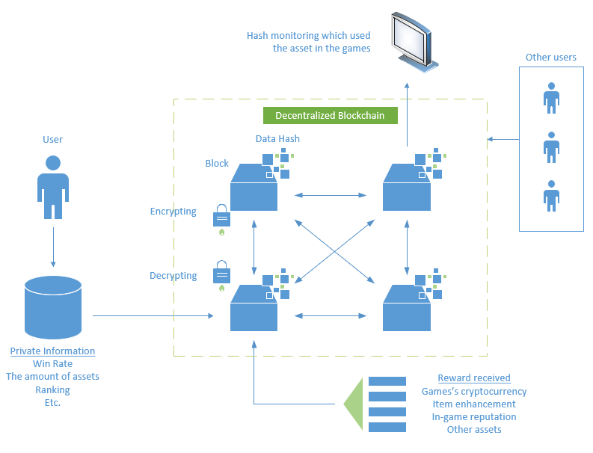

Fig.1 The proposed blockchain architecture of in-game property management

The scenario of our novel application given as the handling property and personal information of users, such as number of assets, ranking, win rate and so on that is encrypted data stored by hash block as a hash data in a decentralized block. The data can be monitored to verify the existence of the property and then be used to display it in the games. This helps to reduce the amount of data that is stored in the central server. As each block holds personal data with Hash data encryption instead.

The trading of in-game items must be confirmed by every block. (Here referring to every user identification that created a block) to confirm the exchange between 2 owners of the property This will make the system more reliable because it has to support the exchange of all accounts (but the confirmation model still runs as an automatic block), which will not have a gap for the cheat user to conjugate and/or spawn illegal items into the game because The origin of that item takes place and occur on the blockchain as hash information only.

The incoming of property whether it is killing monsters in dungeons, participating in the events, the rewards will be returned in the form of in-game cryptocurrency, item enhancement, as well as the user's reputation to complete the acquired awards. Showing the history and the number of hands that have been vastly By telling how good an item is or how important it is Adding value to the item.

**6. Conclusion**

In this paper, the Blockchain technology with its key characteristics and applications are discussed. Since, blockchain technology is increasing and improving day by day and has a really bright future in the upcoming years. Furthermore, we analysed the properties of blockchain into five main ideas. As we have realized that safety is the primary concern everywhere. For an extension of this work, we proposed the novel application for the gaming industry which mainly focused on transparency and trust that led to more secure, efficient and effective in the gaming industry. We believe that the novel application proposed in this report will leverage the gaming industry to continue to perform outstandingly.

As a result, we have learned about all the important features of blockchain technology. In addition, we covered how this Blockchain feature benefits us and applied its properties into our novel application.

**Reference**

https://www2.deloitte.com/us/en/pages/public-sector/articles/blockchain-opportunities-for-health-care.html

https://www.economist.com/sites/default/files/northeastern.pdf

<https://builtin.com/blockchain/blockchain-applications>

https://data-flair.training/blogs/features-of-blockchain/

https://101blockchains.com/introduction-to-blockchain-features/

https://weteachblockchain.org/faq/what-is-decentralization/

https://www.entrepreneur.com/article/318477

https://www.transperfect.com/blog/global-gaming-industry-growth-in-2021

https://www.fraugster.com/resources/post/online-gaming-fraud-trends-2020